|  |  |  |  |
| --- | --- | --- | --- |
| **Team**  **Members** | **No** | **Full Name** | **Student ID** |
| 1. | Aitore Issadykova | 201275926 |
| 2. | Assem Kussainova | 201535798 |

1. **Project Title:** Forecasting stock prices during pandemic times
2. **Bottlenecks:** According to the original proposal, it was planned to study the influence of temperature conditions on the spread of the COVID-19 virus, however, with further deepening in previous studies, it was found that the main trends identified using only statistical methods belonging to only one country (China) do not have the same tendency in situations of other countries. Therefore, it was decided to immediately switch to the proposed alternative plan to study the impact of pandemics on the stock market and accelerate the project due to a tight schedule and an increased load. This may not be considered as a problem as these changes were taken into account in submitted proposal.
3. **Updates to Proposal:** Thus, after the transition to plan B, the main goals and expected results of the project were changed. The main aim of the project changed to behavior prediction of market stock prices during pandemic times such as MERS, SARS and Ebola. Data will be taken from stock price records of companies from different fields, including technical, sales, travel and entertainment industries, for studying effects of pandemics not only in one sphere. The forecasting model built using learning methods like Linear Regression, SVM, LSTM and statistical methods for working with time series like Moving Average, Auto Regression will be trained on mentioned historical records of pandemic times and will be applied to the recent pandemic COVID-19 and behavior of stocks and their prices for next 5-30 days will be predicted. General rate of the project is mostly consistent with previously built schedule.
4. **Activities to Date:** Starting from the first day of the schedule, data, including confirmed cases of infected and a temperature condition, for prediction of the peak cases of COVID-19 was collected for 3 countries: China, Italy and South Korea. After visualizing obtained data it was seen that there’s low correlation between pandemic cases rate and temperature, and there are could be other important factors. For this reason, project has turned to the second proposed direction. During literature review were studied behaviors of stocks in previous pandemic times and learned some trends and tendencies.

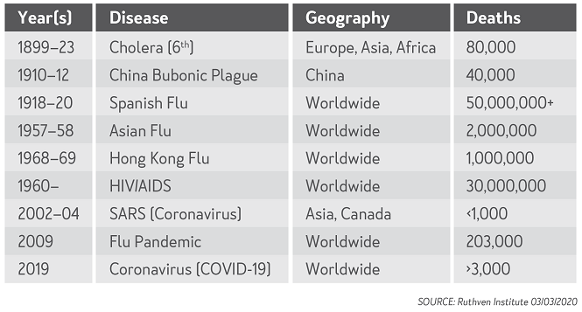

For analysis were chosen the stocks of such companies as Disney, Amazon, American Airlines, Google, Marriott, Samsung, Twitter as they represent different sphere, in the period when pandemics were started, reached their peak and when finished. All data was obtained from Yahoo Finance live stock market website. Models were built using specified methods and trained on historical data. Now is the stage of tuning the models with best parameters for increasing accuracy of prediction and application of statistical methods Moving Average and Auto Regression.

1. **Discoveries and Results:** After visualization of data, it was found that examined companies’ stocks have similar patterns during previous pandemic cases such MERS, SARS and Ebola. As for the accuracy of models trained using several methods, it is seen that at this time SVM and Linear Regression slightly outperform the results of LSTM algorithm, but this achievements in price prediction are not the last ones, as better parameters can be found during next steps before submission of final results.
2. **Remaining Work:** As for the remaining part of the project, there will be continued choice of the most relevant models and enhancement of trained models parameters to find the best accuracy for best prediction. After the tuning of models will be finished, the pandemic COVID-19 data will be examined and the prediction for the close dates will be made. In addition, an influence of this pandemic on Kazakhstani market can be provided. All remaining work will be finished before the submission of final report within 12 days.